Mock Test !
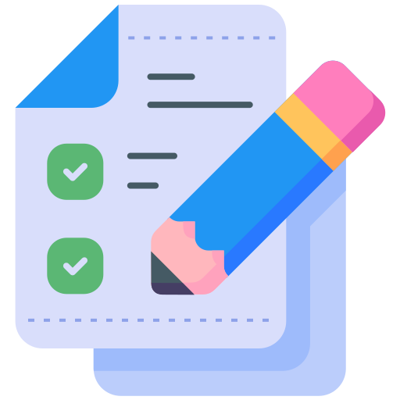

Final Stage: Mock Test Assessment 🎓✨

Congratulations on reaching the final stage of your training program! This is your ultimate challenge: two rounds of Mock Tests—one focused on Retail and the other on F&B.

Unlike the Training Assessment, this is a full-on mock test designed to simulate real training scenarios with a structured training flow that you must follow.

How It Works 📝

- Topics: Your coach will share the topics you need to cover during the Mock Test.
- Preparation: A ticket will be assigned to you one day prior, giving you ample time to prepare.
- Application: Bring all your learning to life! Remember those soft skills from Brand Servicing? This is your moment to shine and apply them.
- Evaluation: Your performance will be assessed using a detailed [OC] Master Scorecard, so give it your best shot!

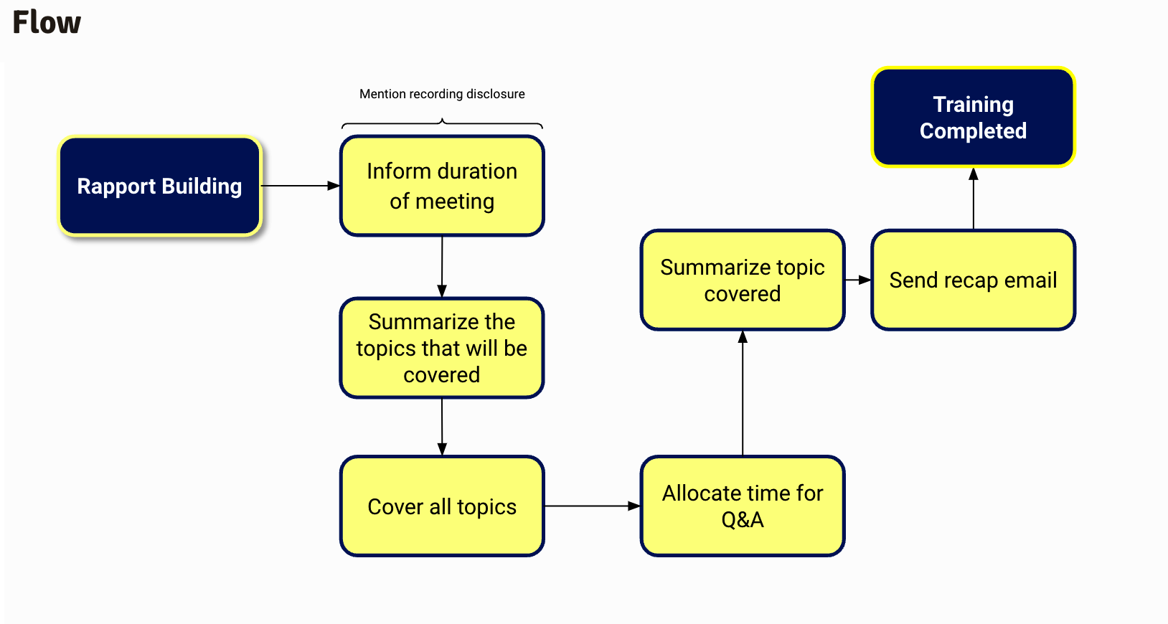
Mock training Flow

Final Tips 🧠💡
- Stay calm and confident—you’ve got this!
- Review your notes and practice the training flow beforehand.
- Focus on both technical accuracy and delivering an excellent experience.

Good luck, and may you ace your Mock Test like a pro! 🚀

